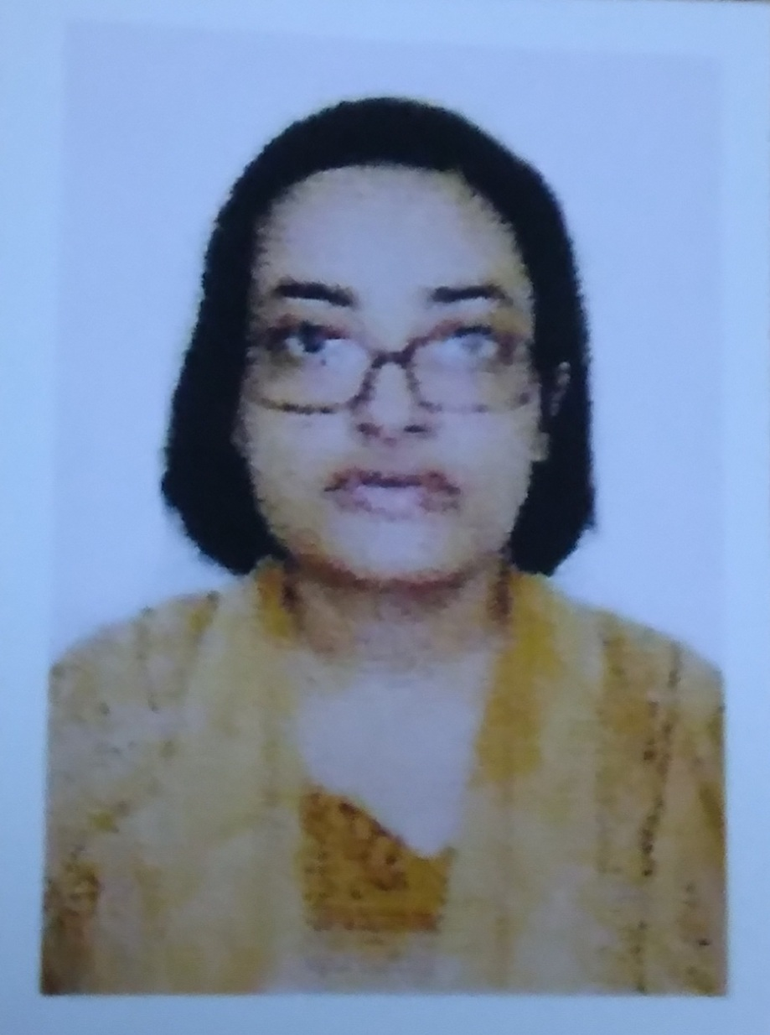

**Name**: DR. SREYASI GHOSH

**Designation**: Asstt. Prof. and HOD , History

**Qualification**: M.A. , Ph.D

**Email**: [-sreyasighosh@yahoo.com](mailto:-sreyasighosh@yahoo.com) , sreyasighosh@hmmcw.in

**Teaching Area**: Ancient , Medieval and Modern Indian History ; History of Medieval and Modern Europe , East Asia , Prehistoric World History.

**Teaching Experience**: 06 years and 03 months in Hiralal Mazumdar Memorial College for Women

**Research Area**: Socio- cultural History of Modern India

**Title of the thesis under Ph D programme: - *Itihas charcha o sanskriti jagate Swadeshi , Pragati o Naxalbari andoloner probhav***

**Post-Doctoral Research**: NA

# Publications:

|  |  |  |  |  |  |  |  |  |
| --- | --- | --- | --- | --- | --- | --- | --- | --- |
| **Title of paper** | **Name of the author/s** | **Department of the teacher** | **Name of journal** | **Year of publication** | **ISSN Number** | **Link to the recognition in UGC enlistment of the Journal /Digital Object Identifier (doi) number** | | |
| Link to website of the Journal | Link to article / paper / abstract of the article | Is it listed in UGC Care list |
| 1. **Cultural Impact of the Anti- Partition Movement (1905) of India** | **Dr.Sreyasi Ghosh** | **History** | **Research Review: International Journal of Multidisciplinary** | **October 2019** | **2455-3085** | https://rrjournals.com/ | https://old.rrjournals.com/past-issue/cultural-impact-of-the-anti-partition-movement-1905-of-india/ | NA |
| **2) Analysis of reflection of the Marxist Cultural Movement ( 1940s) of India in Contemporary Periodicals** | **Same as above** | **Same as above** | **Same as above** | **April 2020** | **Same as above** | Same as above | <https://doi.org/10.5281/zenodo.3822207> | NA |
| **3)Sister Nivedita : Lady with the Lamp in History of the Swadeshi Movement (1905) of India** | **Same as above** | **Same as above** | **Same as above** | **May 2020** | **Same as above** | Same as above | https://doi.org/10.31305/rrijm.2020.v05.i05.003 | NA |
| **4)Cultural Impact of The Naxalite Movement ( 1970s) in Bengal** | **Same as above** | **Same as above** | **Same as above** | **October 2021** | **Same as above** |  | <https://doi.org/10.31305/rrijm.2021.v06.i10.004> | NA |
| **5)Reflection of Socio- Economic and Cultural Turmoil of 1940s and 1950s in Short Stories of Manik Bandopadhyay : a renowned litterateur** | **Same as above** | **Same as above** | **Same as above** | **November 2021** | **Same as above** | Same as above | https://doi.org/10.31305/rrijm.2021.v06.i11.002 | NA |
| **6) Skillful portrayal and reflection of the Naxalite Movement of Bengal ( 1970s) in world of stories** | **Same as above** | **Same as above** | **Same as above** | **April 2022** | **Same as above** | Same as above | <https://doi.org/10.31305/rrijm.2022.v07.i04.007> | NA |
| **7) Analysis of contribution of some renowned artists of the Era of the Marxist Cultural Movement of Bengal** | **Same as above** | **Same as above** | **Same as above** | **October 2022** | **Same as above** | Same as above | https://doi.org/10.31305/rrijm.2022.v07.i10.001 | NA |
| **8) India’s Partition through the lens of Gender: Trauma and Triumph interconnected** | **Same as above** | **Same as above** | **Same as above** | **March 2023** | **Same as above** | Same as above | https://doi.org/10.31305/rrijm.2023.v08.n03.002 | NA |

|  |  |  |  |  |  |  |  |  |  |  |
| --- | --- | --- | --- | --- | --- | --- | --- | --- | --- | --- |
| **Sl. No.** | **Name of the teacher** | **Title of the book/chapters published** | **Title of the paper** | **Title of the proceedings of the conference** | **Name of the conference** | **National / International** | **Year of publication** | **ISBN number of the proceeding** | **Affiliating Institute at the time of publication** | **Name of the publisher** |
|  |  | **NA** |  |  |  |  |  |  |  |  |

# Seminars, Symposiums, Leadership programmes attended:

# Seminars/ Symposiums attended in last 5 years ( 2017-18 to 2021-22)- State level 59; National level 14; International level – 11 ( Total).

# 2022-2023 till now- Total 18 Seminars/ Symposiums attended .

* **Oral presentation**: NIL

# Poster presentation: NIL

# Leadership programme attended: NIL

# Administrative Experiences:-

# Attended Meetings of Examination and Library Sub- Committee as Joint Convenor ( previous); member of Routine , ICC , Students’ Record, Magazine , Museum Conservation, Students’ Grievance Redressal , Service Book related Committees , Students’ Aid and Scholarship Sub- Committee etc., Invitee member of Admission Committee at present ; attended Teachers’ Council/All staff/ all teaching staff/ HOD/ Incharge of all departments related Meetings also and in most of the cases sent brief report about decisions taken in the Meetings to Principal Madam/ IQAC Co- Ordinator/ Bursar/ TCS/Committee Convenors as per instructions ; at present invitee member of Academic Sub- Committee also ; admission duties; Joint Co- Ordinator of AQAR 2021-2022 related Criterion 7 ; SSR 2023 related works ( as Joint Co- Ordinator of Criterion 7 earlier and at present team member of Criterion 2); Covid situation management related Floor supervisor duty in College ; History Dept. related administrative works as HOD from August 2018 onwards till now ; attended College on Sunday for NTS recruitment related official duty in March 2019; Students’ Week celebration related rapporteur works and Womens’ Day celebration related Programme Co- Ordinator works in 2021-2022 session; invigilation duties in College Exams , WBSU Exams , Public Exam duties and checked scripts of both College Tests and WBSU Examinations ( Online Exams) etc.

**Membership of Professional bodies: Life Member of Bangiya Sahitya Parishad ; annual member ( Online) of Paschimbanga Itihas Samsad.**

# Others: NA

**Administrative experiences outside the College**: NA