EVENT ALBUM FORMAT
(PLEASE MAKE SEPARATE FILES FOR EACH SESSION)
HMM College for Women

SESSION: July 2017-June 2018
DEPARTMENT: Education
EVENT NAME | DATE | NO.OF PARTICIPANTS | DESCRIPTION
Educational excursion | From 16.12.2017 to 21.12.2017 | 15 | Visit to Nalanda, Bihar for Educational Excursion with students and teachers of the department

CORRESPONDING PHOTOS WITH EVENT NAME:

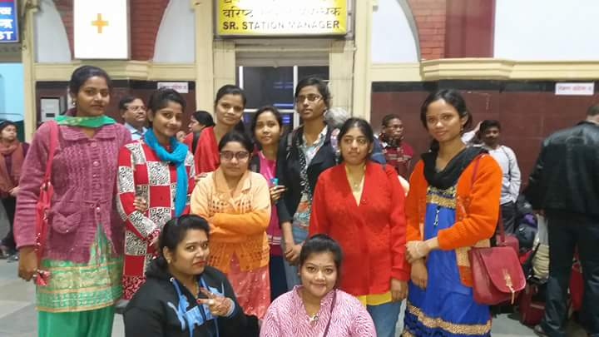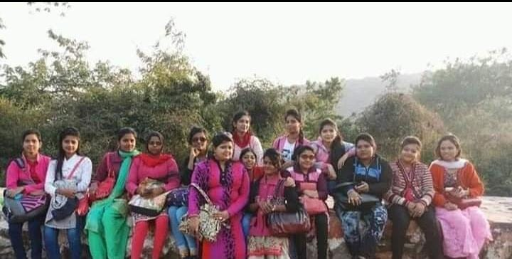
Visit to Nalanda for Educational Excursion with students and teachers of the department

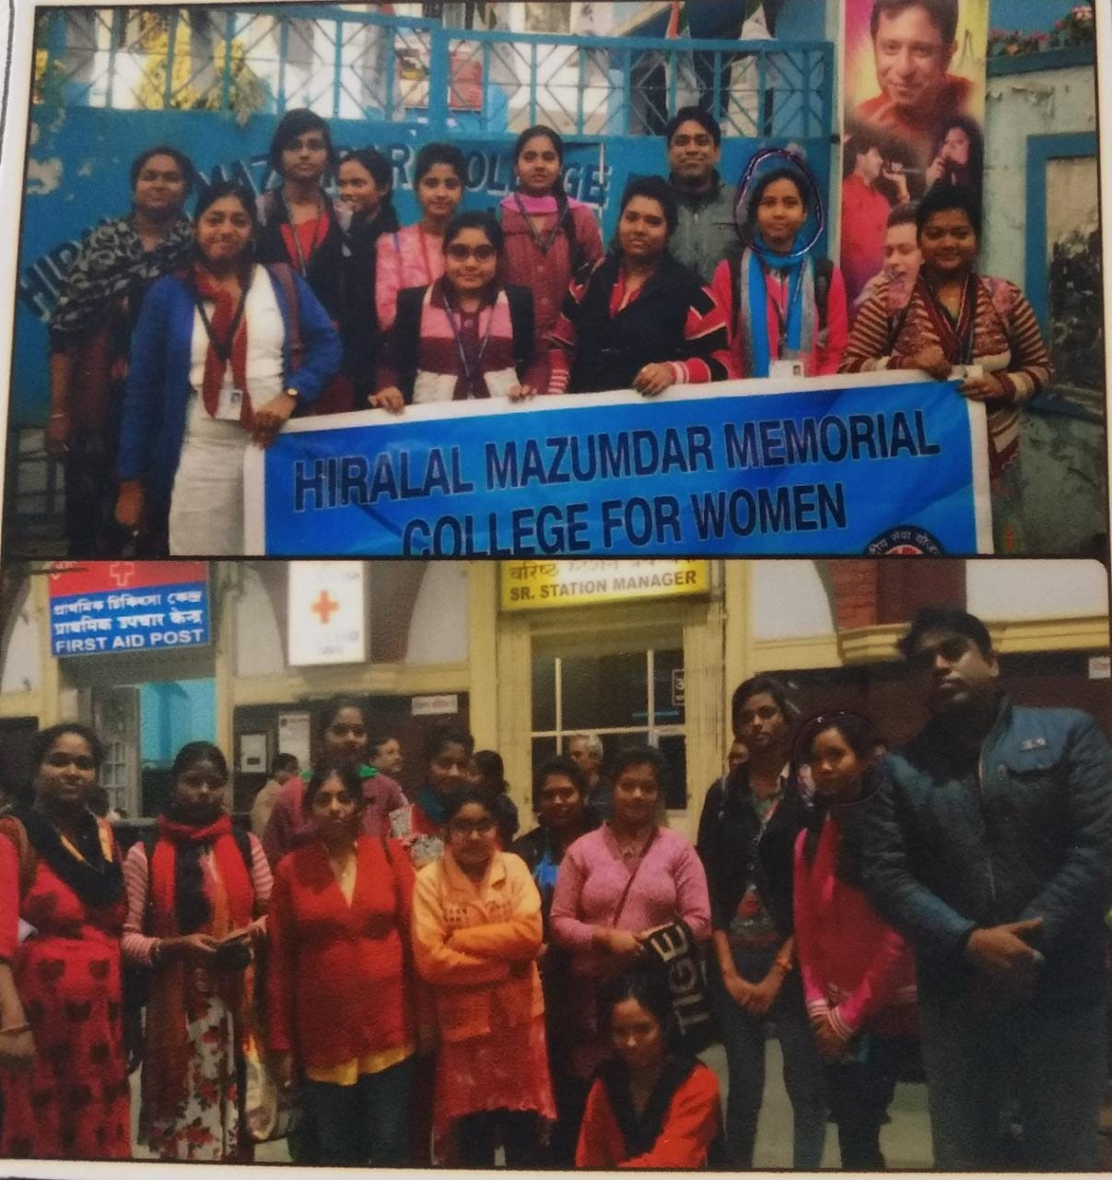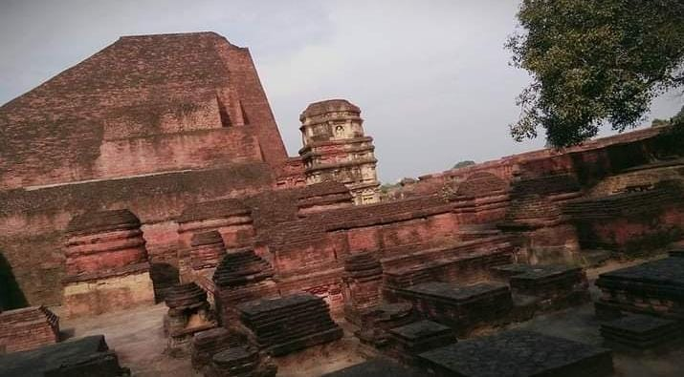

Visit to Nalanda for Educational Excursion with students and teachers of the department

