EVENT ALBUM FORMAT
(PLEASE MAKE SEPARATE FILES FOR EACH SESSION)
HMM College for Women

SESSION: July 2018-June 2019
DEPARTMENT: Education
EVENT NAME | DATE | NO.OF PARTICIPANTS | DESCRIPTION
Educational excursion | From 10.11.2018 to 13.11.2018 | 12 | Visit to Benaras for Educational Excursion with students and teachers of the department
SEMINAR ON VALUE EDUCATION | 29.03.2019 | 40 | A seminar was organized by the BELUR MATH ,Howrah and association with Department of Education.  Some of respected monk was came to enlighten us about the value education .The seminar was so resourceful and informative.

CORRESPONDING PHOTOS WITH EVENT NAME:
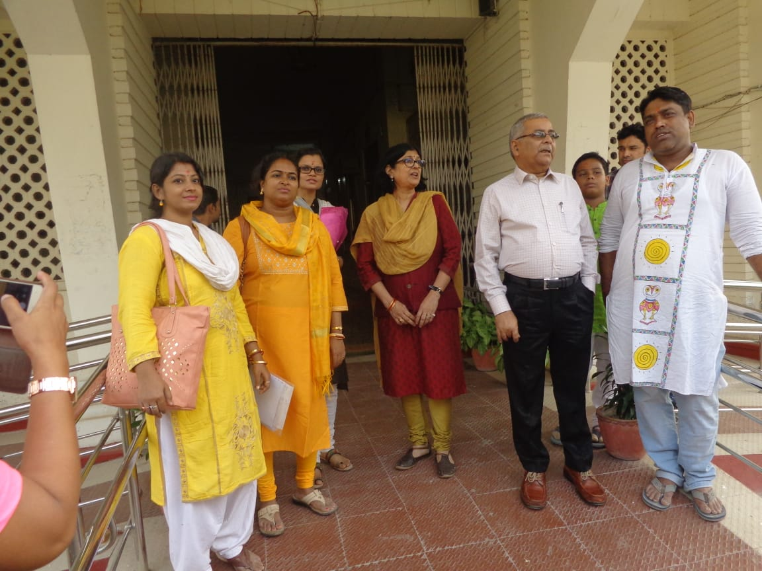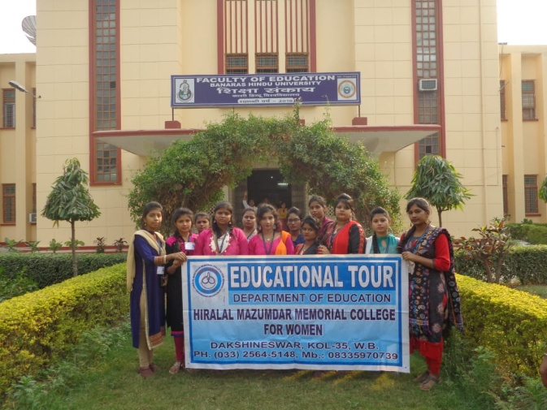

Visit to Benaras for Educational Excursion with students and teachers of the department

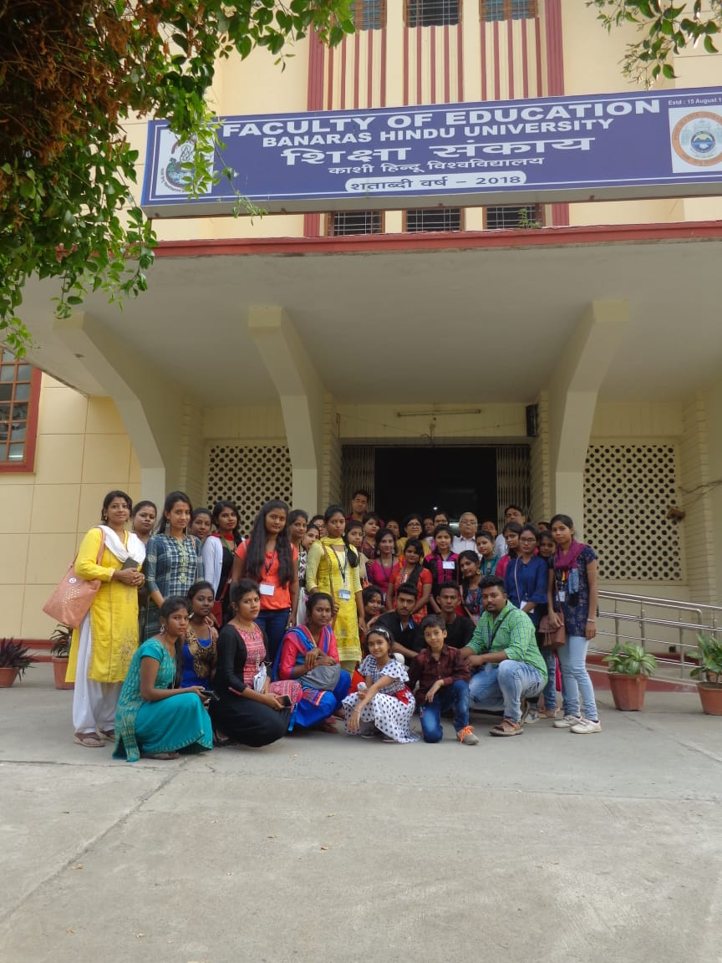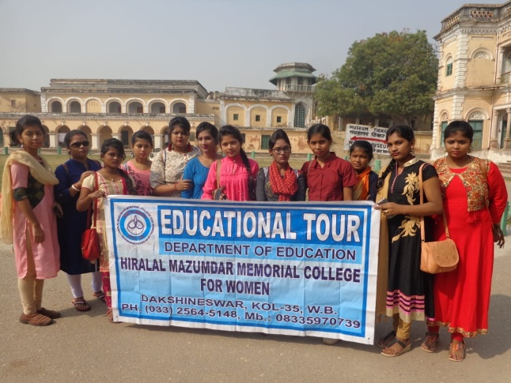

Visit to Benaras for Educational Excursion with students and teachers of the department
