EVENT ALBUM FORMAT
(PLEASE MAKE SEPARATE FILES FOR EACH SESSION)
HMM College for Women

SESSION: July 2019-June 2020
DEPARTMENT: Education
EVENT NAME | DATE | NO.OF PARTICIPANTS | DESCRIPTION
Educational excursion | From 01.11.2019 to 05.11.2019 | 6 | Visit to Ranchi, Jharkhand for Educational Excursion with students and teachers of the department
Extension lecture on "History of Education: Policy Making in India (1600-2010)" | 11-02-2020 | 40 (Approx.) | Delivered by Dr. Ajit Mondal, Assistant Professor, WBSU
One day National Webinar On 'Implication Yoga in Era of Pandemic' | 21-06-2020 | 193 | Organized by the Department of Education ,HMMCW
Two day National e-conclave on "Online Education Pedagogy in Modern Management of Higher Education & Business Studies" | 28th -29th June, 2020 | 108 | Jointly organized by the Department of MBA,NBU and Department of Education and IQAC,HMMCW

CORRESPONDING PHOTOS WITH EVENT NAME:

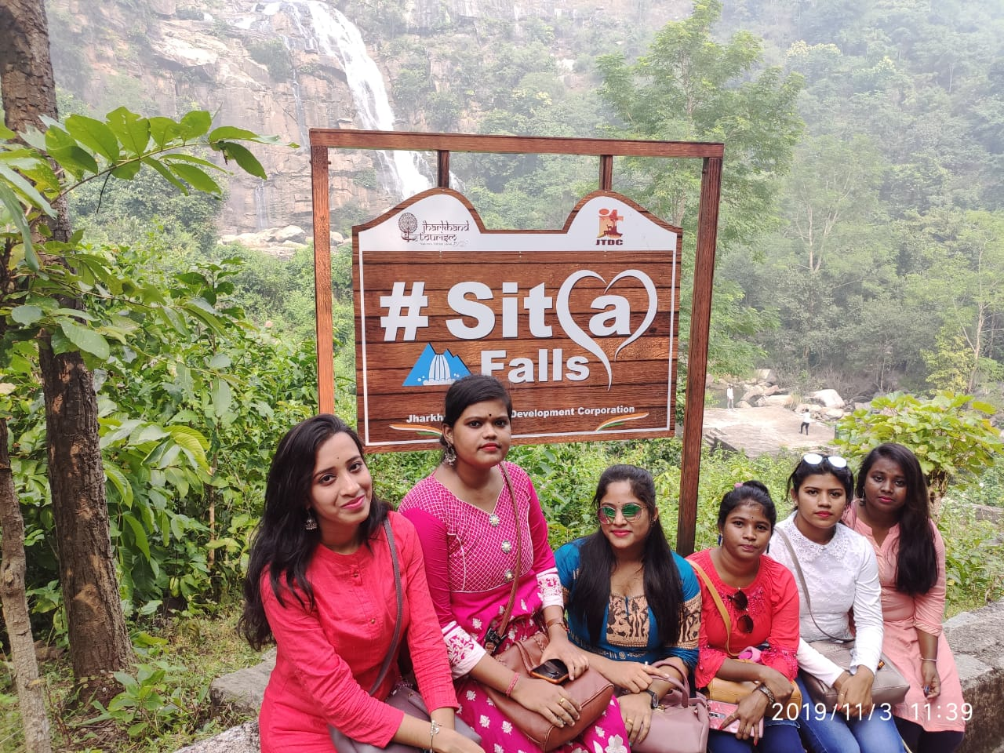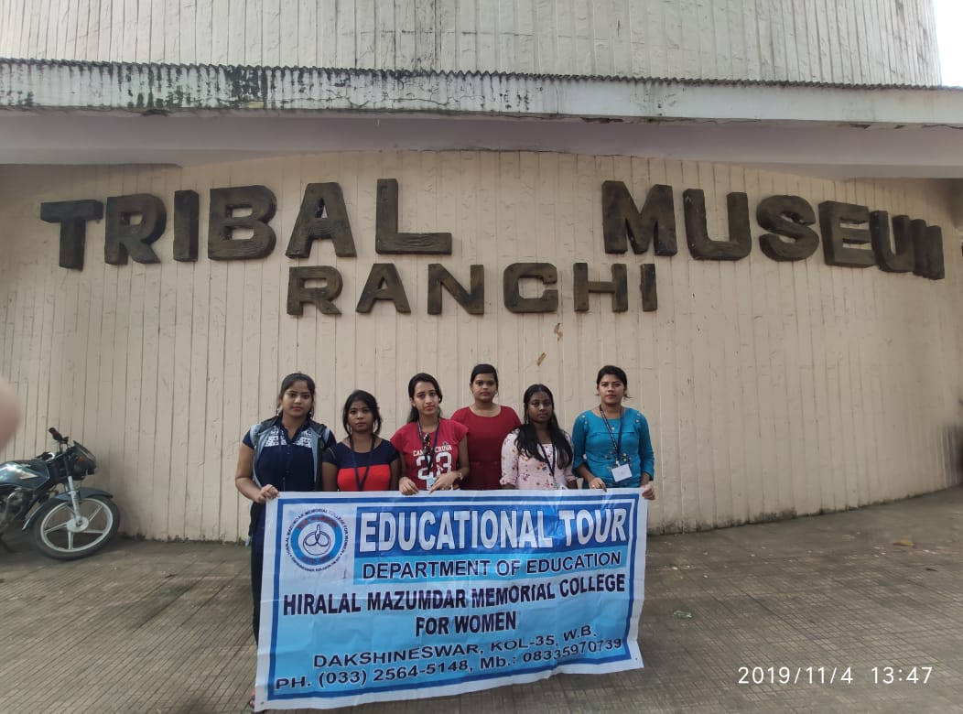
Visit to Ranchi, Jharkhand for Educational Excursion with students and teachers of the department

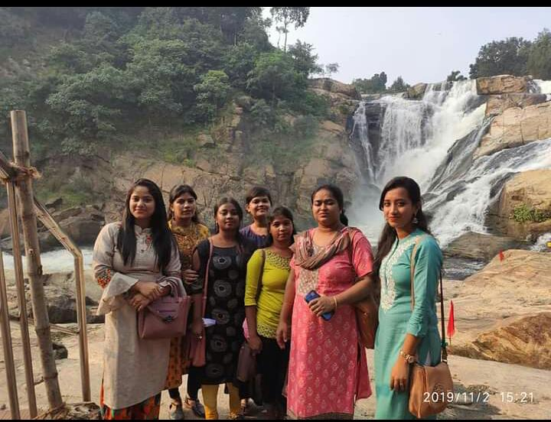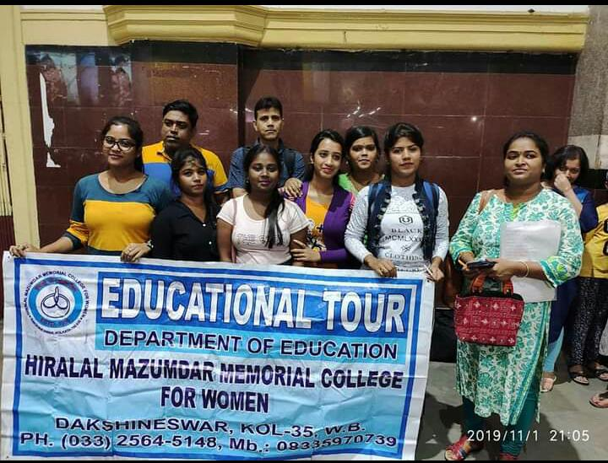
Visit to Ranchi, Jharkhand for Educational Excursion with students and teachers of the department

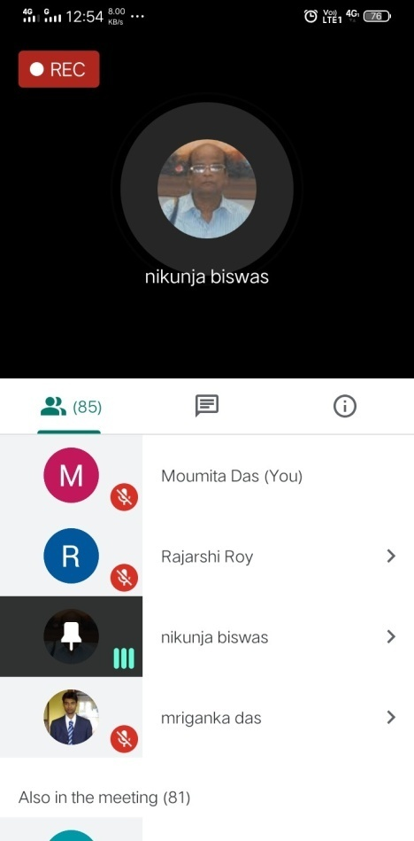
Two day National e-conclave on "Online Education Pedagogy in Modern Management of Higher Education & Business Studies" (held on 28th -29th June, 2020).
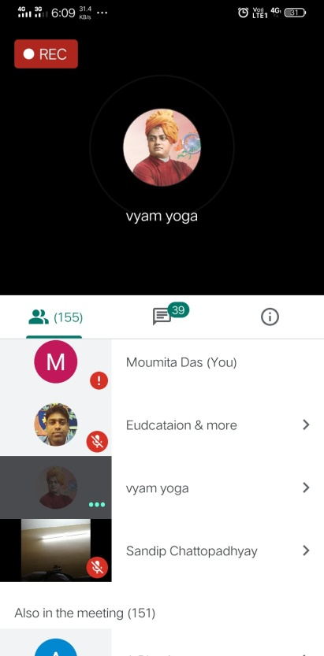
One day National Webinar On 'Implication Yoga in Era of Pandemic' (held on 21-06-2020)
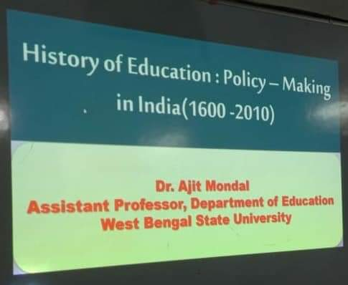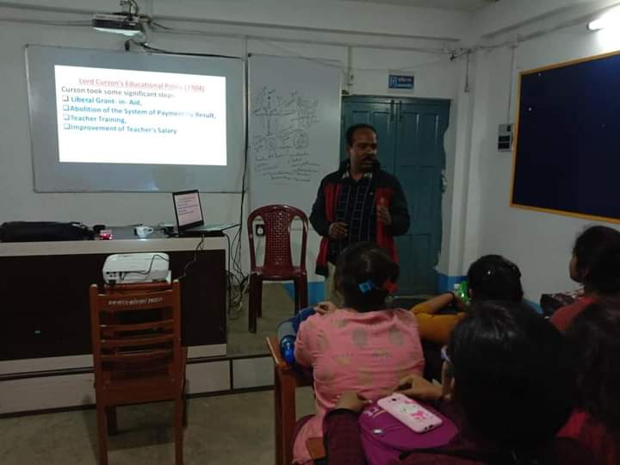
Extension lecture on "History of Education: Policy Making in India (1600-2010)" (held on 11-02-2020)

