**HIRALAL MAZUMDAR MEMORIAL COLLEGE FOR WOMEN**

**DEPARTMENT OF BOTANY**

**EVENT REPORT 2024-25**

**STUDENT’S SEMINAR**

Department of Botany organized a student’s seminar on 6th August, 2024. The venue of seminar is the departmental room that is C-216.On this seminar students were prepared their own presentation under the guidance of various teachers of department of Botany. It starts at about 12 noon and ended at 2pm. On this seminar students of 2nd semester major and minor were participated and delivered their valuable speech on their own topic and also presented their presentation through LCD projector in the form of ppt. Participating students also submitted the hard copy of their won topic. Here mainly the topics were selected from the syllabus of semester –ll Major and Minor under the paper code of BOTDSC202T AND BOTCOR202T respectively.

Finally we successfully completed the program of student’s seminar and all the students of above mentioned semester were participated.

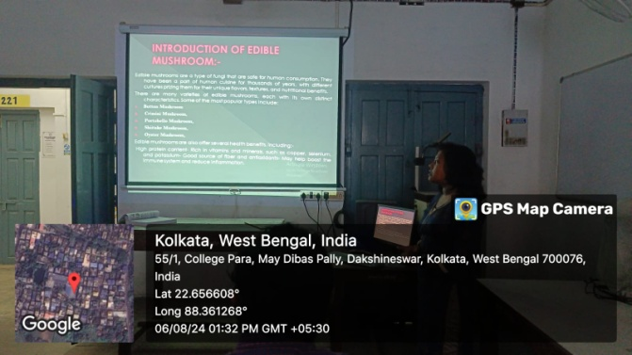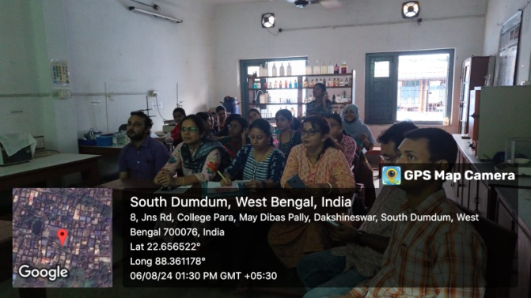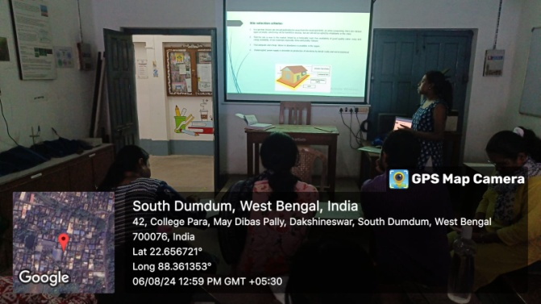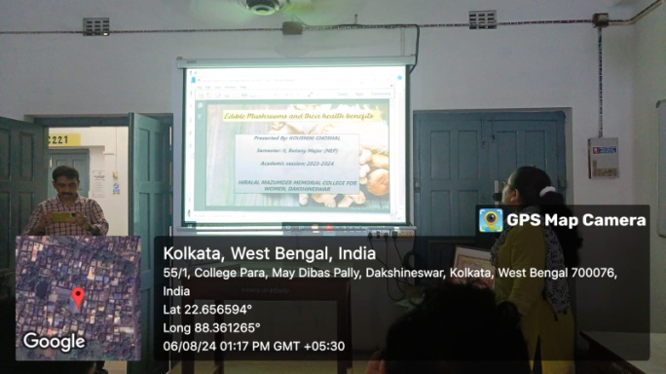

**WORKSHOP ON ECO-FRIENDLY RAKHI MAKING**

The workshop on eco-friendly Rakhi making was organized by the Department of Botany with the Green Club at Hiralal Mazumdar Memorial College for Women in Dakshineswar on 9th August, 2024 at 12 noon onwards in the venue of college campus. It starts at 10 am and ended at about 4 pm here many students of our college mainly the students of art and craft were participated and prepared the eco-friend Rakhi under the guidance of Smt. Munmun Kundu. Ultimately they successfully prepared a lots of Eco-friend Rakhi and now a day’s these types of Rakhi had a great significance as there were no pollution effect and did not causes any harmful effect on environment after the uses of Rakhi.

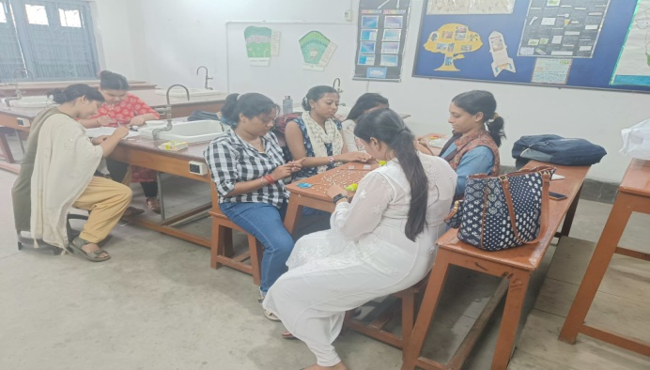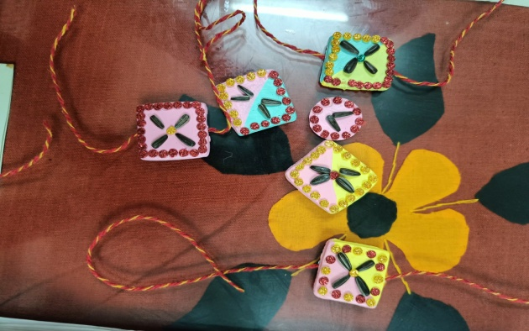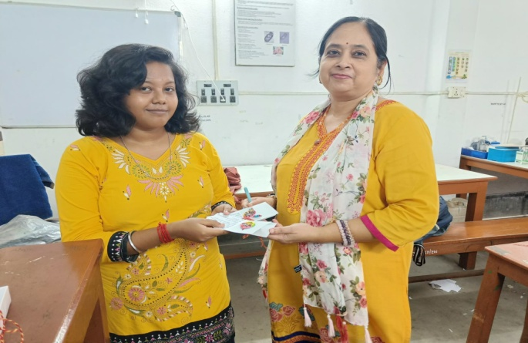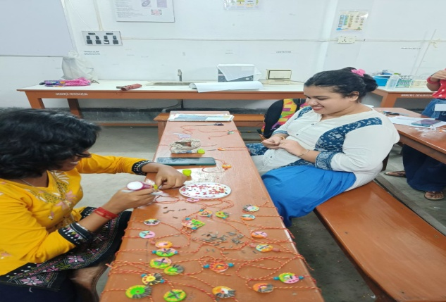

**HANDS ON TRAINING ON HERBARIUM TECHNIQUE**

Department of Botany of Hiralal Mazumdar Memorial College for Women in Dakshineswar with the collaboration of the Department of Botany of of Sarojini Naidu College for Women organized a hands on training on Herbarium Technique on 13th August, 2024 at 12 noon. The total hands on training programmed consists of two phases – on the first phase Dr Namrata Shanu Gupta delivered her valuable lecture on herbarium making technique and on the second phase Smt. Munmun Kundu performed the hands on training programmed and teach to students how herbarium was making. On these programmed students of 2nd semester Major and Minor, 4th semester Hons and 1st semester minor of both the above mentioned colleges were participated.

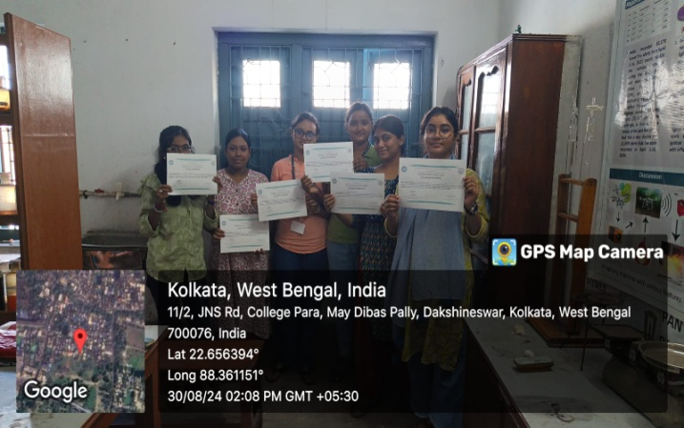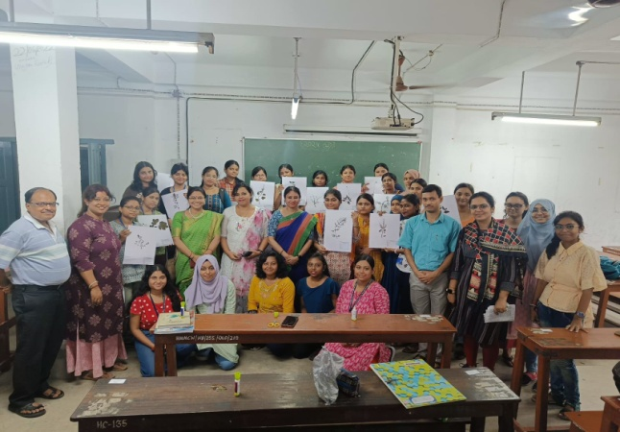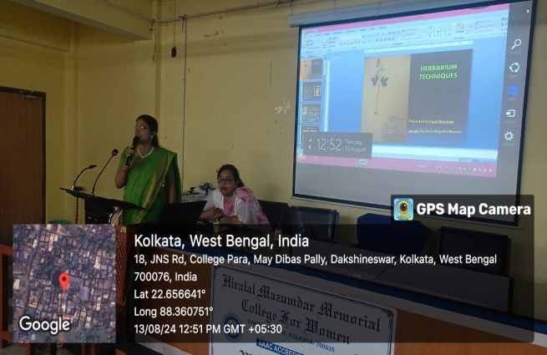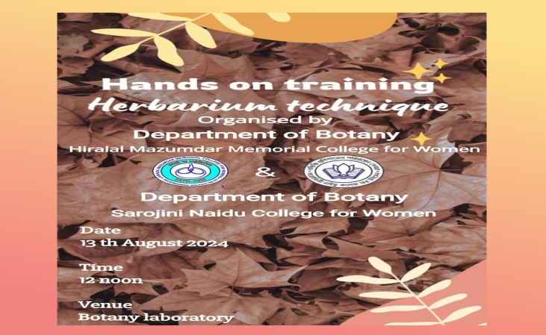

**LOCAL EXCURSION**

Under the guidance of Dr. Madhushri Das Datta and Smt. Munmun Kundu the students of 4th semester Hons and 2nd Semester Minor visited a local excursion within Dakshineswar area on 30th August, 2024. The Excursion was started from 1pm and ended at 3pm. From these local excursion students were collected various herbaceous plants for their Herbarium making purpose and they also learned how to collect the herbaceous plants for herbarium making purpose

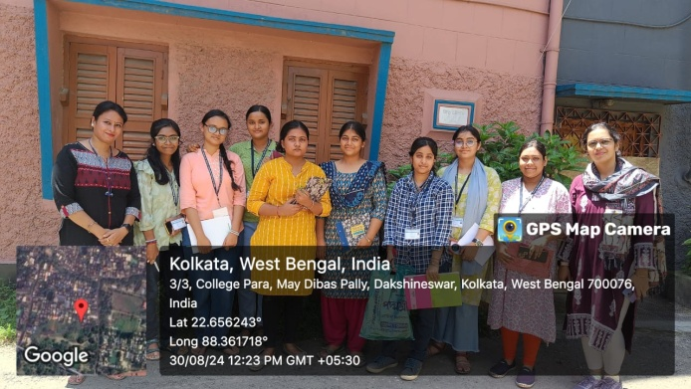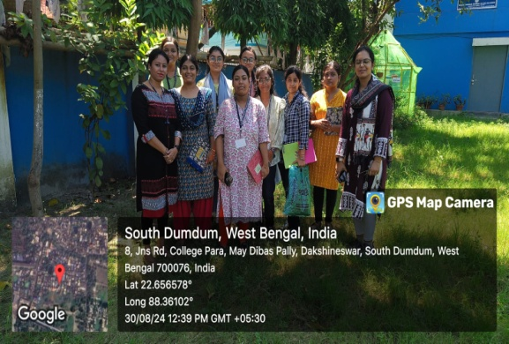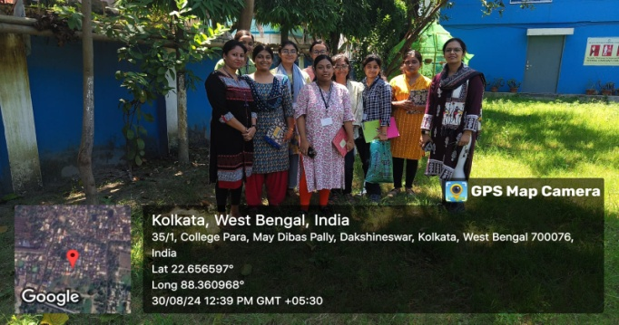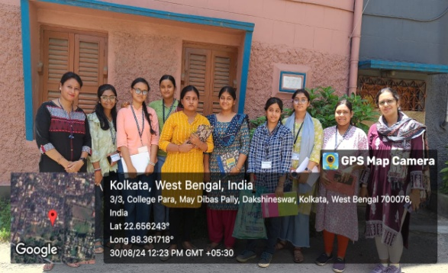

**VISIT TO NATIONAL FOOD LABORATORY, KOLKATA FSSAI**

Department of Botany with the collaboration of department of Chemistery and Food and nutrition of Hiralal Mazumdar Memorial College for Women in Dakshineswar arranged a short tour to national food laboratory, Kolkata on 3rd January, 2025. All the students of 3rd semester major participated in this tour. Under the guidance of of Dr. Madhushri Das Datta students took a great knowledge about food industry. They started tour at about 1 pm and it was ended at about 5 pm.

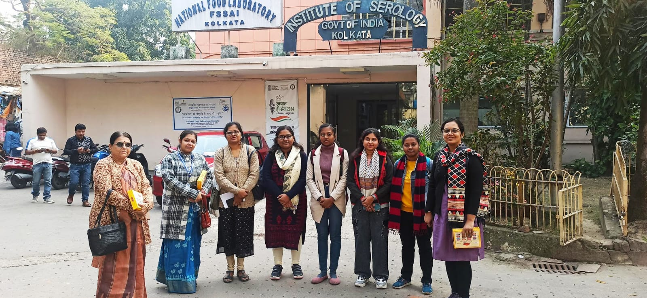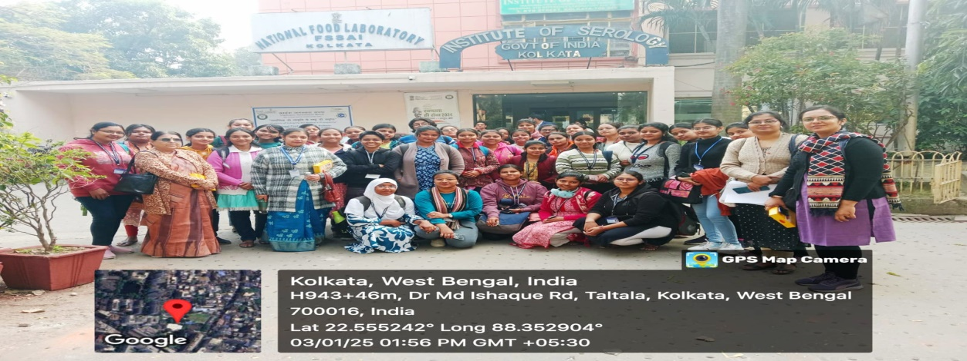

**EXCURSION TO AJC BOSE INDIAN BOTANIC GARDEN**

Department of Botany of Hiralal Mazumdar Memorial College for Women in Dakshineswar had organized a study excursion to the Acharya Jagadish Chandra Bose Indian Botanic Garden, Botanical Survey of India (BSI), ON 17TH January2025. The excursion was commence at 10ː30 an and ended at about 5pm. Here the students of 1st and 3rd semester major and minor were participated under the guidance of all the teaching members of Department of Botany.

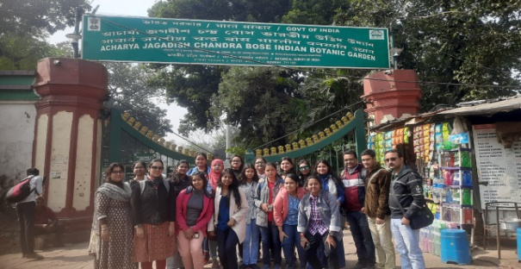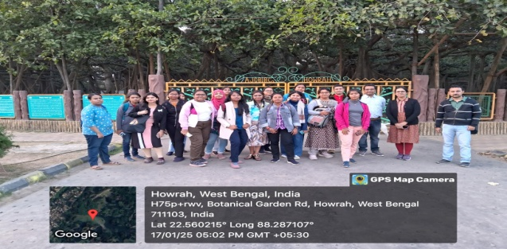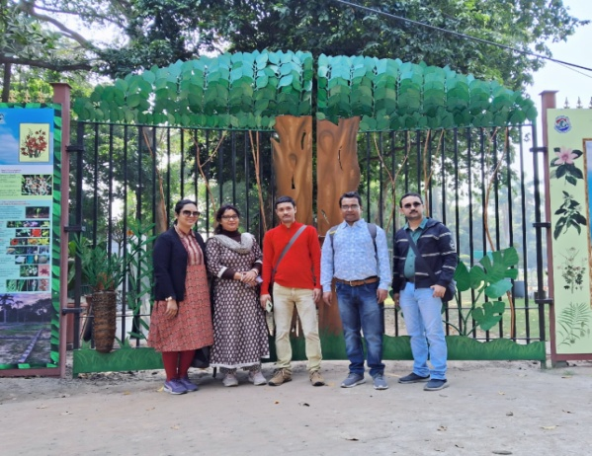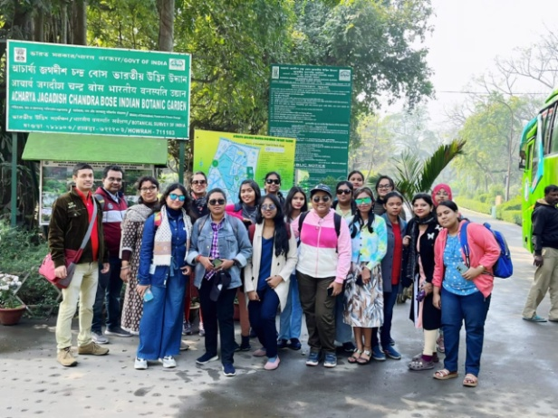

**VISIT TO BISKFARM FACTORY**

Department of Botany with the collaboration of department of Chemistery and Food and nutrition of Hiralal Mazumdar Memorial College for Women in Dakshineswar arranged a short tour to Biskfarm Factory, Dhulagori on 7TH February, 2025. All the students of 3rd semester major participated in this tour. Under the guidance of of Dr. Madhushri Das Datta students took a great knowledge about food industry. They started tour at about 1 pm and it was ended at about 5 pm.

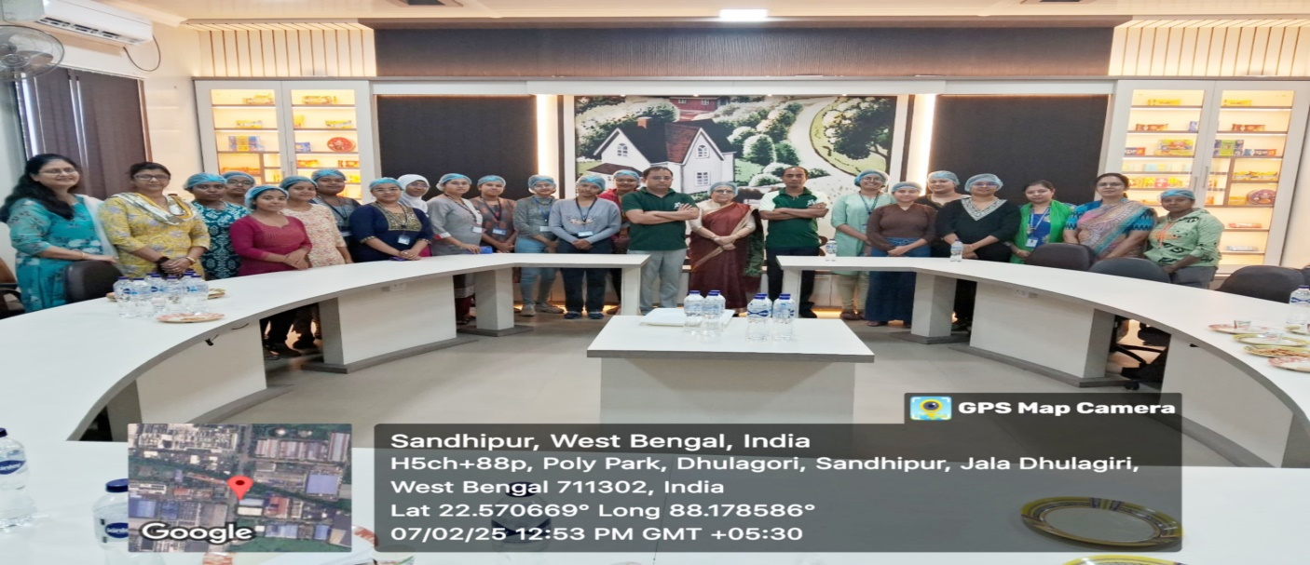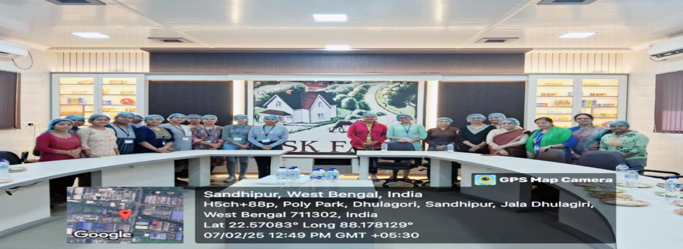

**STUDENT’S SEMINAR**

Department of Botany organized a student’s seminar on 11th and 12th April, 2025. The venue of seminar is the departmental room that is C-216.On this seminar students were prepared their own presentation under the guidance of various teachers of department of Botany. It starts at about 1pm and ended at 2pm. On this seminar students of 3rd semester minor were participated and delivered their valuable speech on their own topic and also presented their presentation through LCD projector in the form of ppt. Participating students also submitted the hard copy of their won topic. Here mainly the topics were selected from the syllabus of semester –lll Minor under the paper code of BOTHSEC202M.

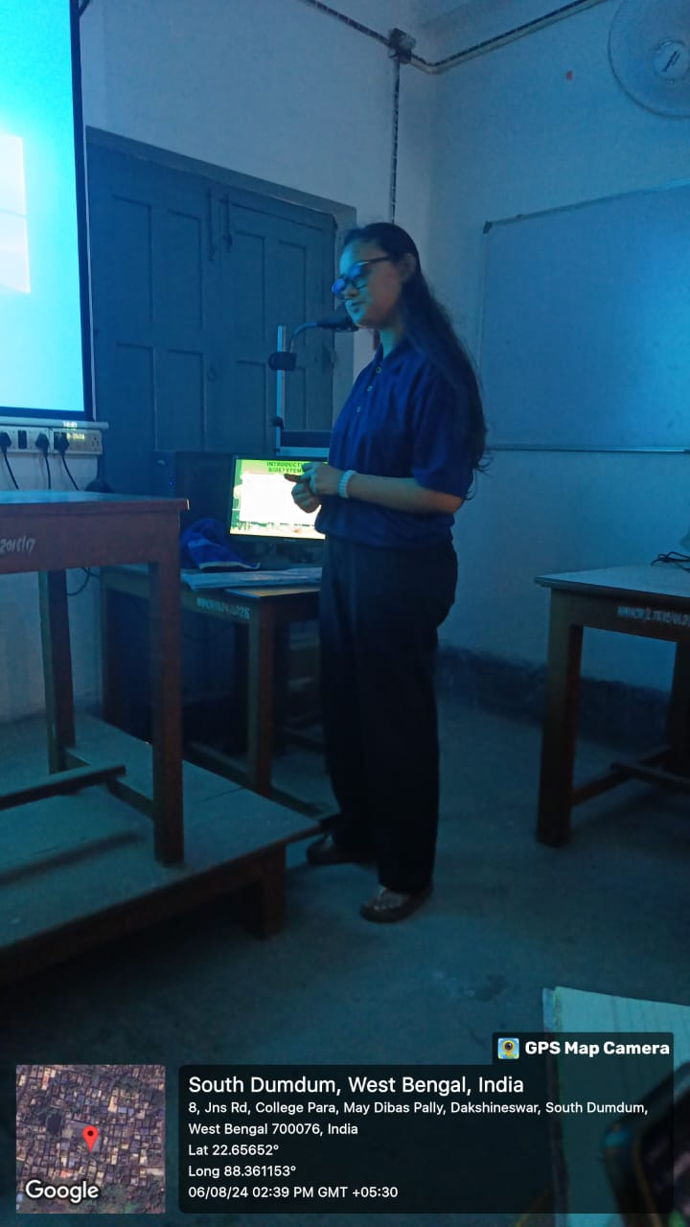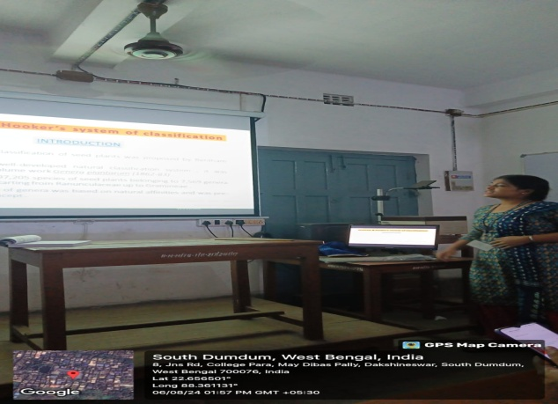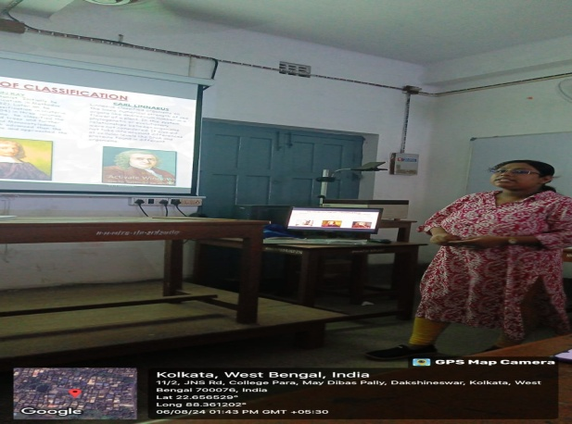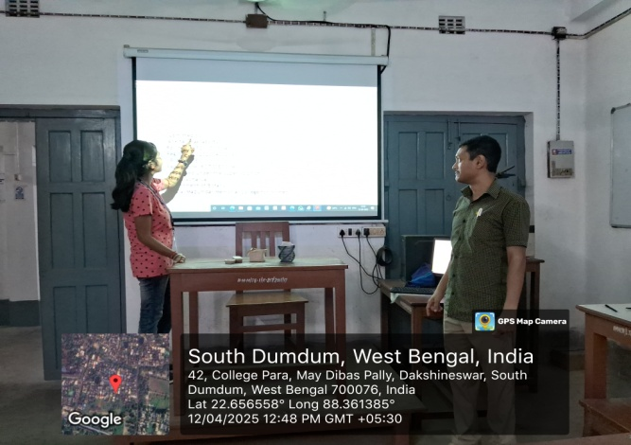

**HERBAL ABIR MAKING WORKSHOP**

An Herbal Abir Making Workshop was organized by the Department of Physiology, Chemistry and Botany in collaboration with IQAC, Incubation Centre and Entrepreneurial Development Cell ofthe College on 21ST February, 2025 from 12 noon and ended at about 4pm. This workshop was conducted by the Paschimbanga Bigyan Mancha at the College premises. The workshop aimed to promote ecofriendly natural colors for Holi. The event started with an awareness session highlighting the harmful effects of synthetic abir on health and the environment. Experts from Paschimbanga Bigyan Mancha explained the benefits of herbal colors. The participants learned about natural ingredients used for making abir: Such as- Yellow and Orange Marigold flowers for Yellow and Orange colored Abirs respectively, Rosepetals for Pink, Butterfly Pea Flower for Blue and Spinach for Green colored Abirs. Arrowroot powder was used as a base for smooth texture. The incorporation of food color and natural essences in herbal abir enhanced its vibrancy and fragrance while ensuring safety for skin and the environment. Natural food-grade colors were used to intensify the shades of herbal abir.They are non-toxic, skin-friendly, and biodegradable, making them safer alternatives to synthetic dyes. The demonstration showed how to dry, grind, and mix these ingredients to create vibrant shades. Students actively participated in preparing herbal abir in small groups

The workshop successfully enhanced scientific awareness and encouraged students to adopt eco-friendly practices. Many students expressed interest in learning and promoting herbal abir in future Holi events. Students planned to distribute these herbal colors (abirs) in the community before Holi, promoting a safe and sustainable celebration.

