Hiralal Mazumdar Memorial College for Women
Extension lectures organised by Department of EDUCATION 2019-2020

SESSION: July 2019-June 2020
DEPARTMENT: Education
EVENT NAME | DATE | NO.OF PARTICIPANTS | DESCRIPTION
Extension lecture on "History of Education: Policy Making in India (1600-2010)" | 11-02-2020 | 40 (Approx.) | Delivered by Dr. Ajit Mondal, Assistant Professor, WBSU

CORRESPONDING PHOTOS WITH EVENT NAME:

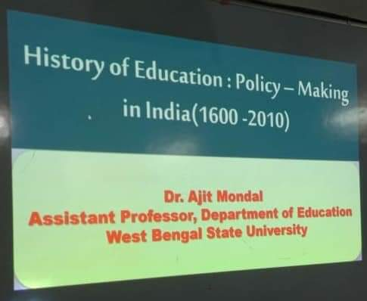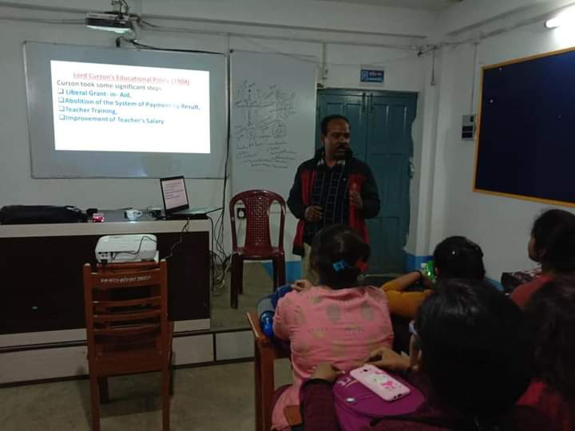
Extension lecture on "History of Education: Policy Making in India (1600-2010)" (held on 11-02-2020)

