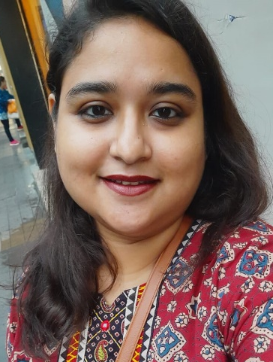

Name: Smt. Aatreyee Bhattacharyya
Designation: State Aided College Teacher
Qualification: M.A. , SET
Email: aatreyeebhattacharyya@hmmcw,in

Teaching Area: Medieval History, South East Asian History, Medieval Europe
Teaching Experience: Since 2019

Research Area: Medieval Bengal

Publications:

Sl. No. | Name of the teacher | Title of the book/chapters published | Title of the paper | National / International | Year of publication | ISBN number of the proceeding | Affiliating Institute at the time of publication |  | Name of the publisher
01 | AATREYEE BHATTACHARYYA | TOURISM : A THOUGHT ABOUT THE KOLKATA AND ITS HISTORY |  | INTERNATIONAL | 2021 | 978-613-8-95979-3 |  | HMM COLLEGE FOR WOMEN | SCHOLARS PRESS
02 | AATREYEE BHATTACHARYYA | NETAJICHARCHA | NETAJI O FASCIBAD : EKTI SANKHIPTO ALOCHONA | NATIONAL | 2022 | 978-93-90873-94-4 |  | HMM COLLEGE FOR WOMEN | AVENEL PRESS

Seminars, Symposiums, Leadership programmes attended:

Presentation:
- Presented paper on “ WOMEN SAFETY-AN IRONY OF INDIAN SOCIETY-AN OVERVIEW” in the webinar ‘SOME CONCERNS AND MISCONCEPTIONS ABOUT THE ICC’ organized by HIRALAL MAZUMDAR MEMORIAL COLLEGE FOR WOMEN IN COLLABORATION WITH GOVERNMENT GIRLS’ GENERAL DEGREE COLLEGE on 13th February 2021.
- Presented paper on “ COVID 19 PANDEMIC AND CHILD LABOUR: STORY OF INDIRECT IMPACT” in the webinar ‘CHILD LABOUR’ ORGANIZED BY DEPARTMENT OF ECONOMICS AND DEPARTMENT OF COMMERCE, HIRALAL MAZUMDAR MEMORIAL COLLEGE FOR WOMEN on 12th June 2021

Leadership programme attended: Attended several Staff Development Programs and Faculty Development Program

Administrative Experiences:

Engaged in various Administrative activities of the College. Member of various committees of the College like Technical Committee , Museum Conservation Committee, Research Development Cell, etc.
Membership of Professional bodies: Member , Asiatic Society

Others:
Administrative experiences outside the College: Member ,IPR Cell , New Alipore College

