Photograph

Name: SARBAJAYA BANERJEE
Designation: STATE AIDED COLLEGE TEACHER (CATEGORY II)
Qualification: M.A, B.Ed
Email: sarbajayabanerjee@hmmcw.in

Teaching Area: English
Teaching Experience:
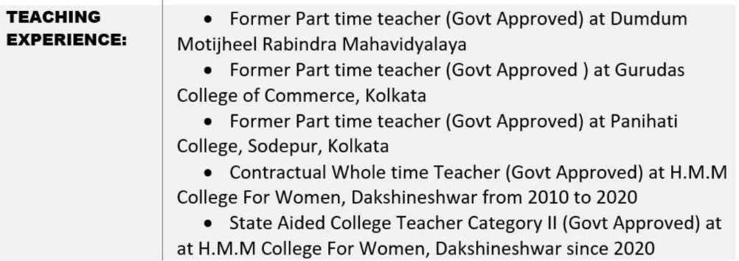

Research Area: NOT APPLICABLE

Title of the thesis under Ph D programme: NOT APPLICABLE
Post-Doctoral Research: NOT APPLICABLE

Publications:

Title of paper | Name of the author/s | Department of the teacher | Name of journal | Year of publication | ISSN Number | Link to the recognition in UGC enlistment of the Journal /Digital Object Identifier (doi) number
 |  |  |  |  |  | Link to website of the Journal | Link to article / paper / abstract of the article | Is it listed in UGC Care list

Sl. No. | Name of the teacher | Title of the book/chapters published | Title of the paper | Title of the proceedings of the conference | Name of the conference | National / International | Year of publication | ISBN number of the proceeding | Affiliating Institute at the time of publication | Name of the publisher

Seminars, Symposiums, Leadership programmes attended: NOT APPLICABLE

- Oral presentation: NOT APPLICABLE

Poster presentation: NOT APPLICABLE

Leadership programme attended: NOT APPLICABLE

Administrative Experiences: NOT APPLICABLE

Membership of Professional bodies: NOT APPLICABLE

Others:
Administrative experiences outside the College: NOT APPLICABLE

