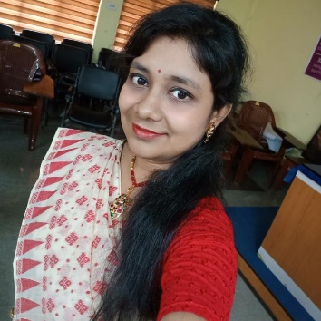

Name: Triparna Sett
Designation: State Aided College Teacher
Qualification: M.A.
Email: triparnasett@hmmcw.in
Teaching Area: Sociological Theory, Thought, Rural and Urban Sociology, Sociology of Kinship, Political Sociology etc.
Teaching Experience: 3 years 10 months approx..

Research Area: Urban Sociology, Sociology of Stratification

Title of the thesis under Ph D programme: N.A.
Post-Doctoral Research: N.A.

Publications:

Title of paper | Name of the author/s | Department of the teacher | Name of journal | Year of publication | ISSN Number | Link to the recognition in UGC enlistment of the Journal /Digital Object Identifier (doi) number
 |  |  |  |  |  | Link to website of the Journal | Link to article / paper / abstract of the article | Is it listed in UGC Care list
 | Triparna Sett | Sociology | CharchaProkash, A Multi-disciplinary Peer Reviewed Academic Journal of Teachers' Council, Basirhat College | 2022 | 2249 - 331X

Sl. No. | Name of the teacher | Title of the book/chapters published | Title of the paper | Title of the proceedings of the conference | Name of the conference | National / International | Year of publication | ISBN number of the proceeding | Affiliating Institute at the time of publication | Name of the publisher
1. | Triparna Sett | THAKUMAR JHULI AND CHILDHOOD: CRITICAL ANALYSIS OF THAKUMAR JHULI AND PRESENTATION OF PREPOSTEROUS WORLD  In  THE JOURNEY OF CHILDHOOD AND INTERSECTIONALITY- SOME REFLECTIONS |  | THE JOURNEY OF CHILDHOOD AND INTERSECTIONALITY- SOME REFLECTIONS | Childhood and Intersectionality in the Indian Context | National | 2020 | 978-81-949068-7-2 | HMMCW | Avenel Press

Seminars, Symposiums, Leadership programmes attended:

- Oral presentation: N.A.

Poster presentation: N.A.

Leadership programme attended: N.A.

Administrative Experiences: Member of Admission Sub-Committee.

Membership of Professional bodies: N.A.

Others:
Administrative experiences outside the College:

Other Activities: Project work on “Challenges and Possibilities of Education System in COVID 19 pandemic situation among the slum children in Kolkata: A Sociological Analysis” done during 2021-22. Principal Investigators: Oendrila Dutta and Triparna Sett.

