Name: Anindita Samanta
Designation: SECT II
Qualification: M.Sc, B.Ed
Email: aninditanupur29@gmail.com

Teaching Area: Geomorphology, Soil geography
Teaching Experience: 20 yrs+

Research Area: N.A

Title of the thesis under Ph D programme: Nil
Post-Doctoral Research: N.A

Publications:

Title of paper | Name of the author/s | Department of the teacher | Name of journal | Year of publication | ISSN Number | Link to the recognition in UGC enlistment of the Journal /Digital Object Identifier (doi) number
 |  |  |  |  |  | Link to website of the Journal | Link to article / paper / abstract of the article | Is it listed in UGC Care list

Sl. No. | Name of the teacher | Title of the book/chapters published | Title of the paper | Title of the proceedings of the conference | Name of the conference | National / International | Year of publication | ISBN number of the proceeding | Affiliating Institute at the time of publication | Name of the publisher

Seminars, Symposiums, Leadership programmes attended:

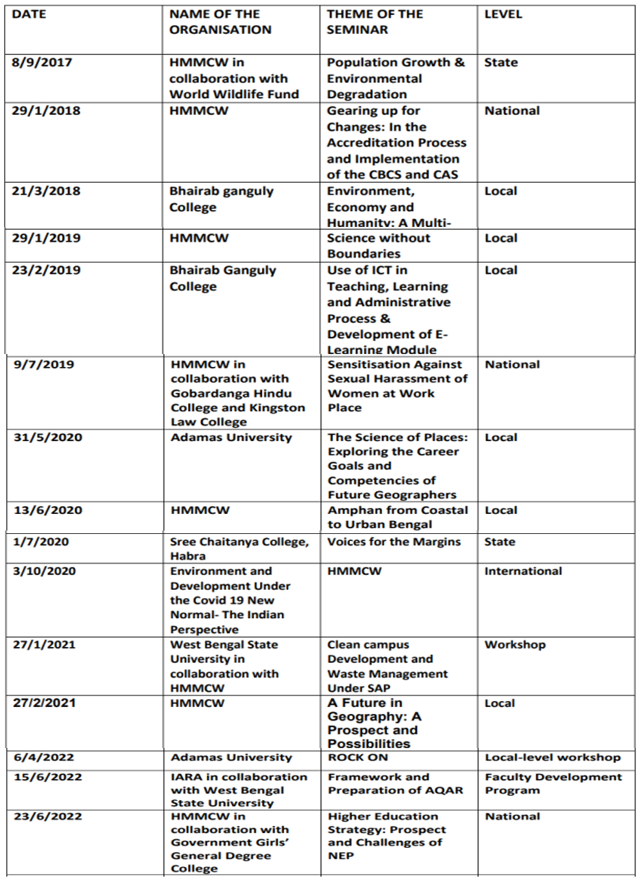

Administrative Experiences: Involved in NAAC related committee

