**EXCURSION TO DAKSHINESWAR AND ADJACENT AREA**

On August 30, 2024, the students of the 4th Semester (Hons) and 2nd Semester (Minor) embarked on a local excursion to the Dakshineswar area, under the expert guidance of Dr. Madhushri Das Datta and Smt. Munmun Kundu. The excursion commenced at 1 pm and provided a valuable learning experience for the students.

The primary objective of the excursion was to familiarize students with herbaceous plant collection and herbarium techniques. During the excursion, students successfully collected various herbaceous plant specimens, gaining hands-on experience in:

1. Identifying and collecting plant specimens

2. Understanding herbarium techniques

3. Learning proper methods for preserving and documenting plant samples

The local excursion proved to be an enriching experience for the students, providing them with practical knowledge and skills in botany. The students expressed their gratitude to Dr. Madhushri Das Datta and Smt. Munmun Kundu for their guidance and expertise. Future excursions can build upon this experience, exploring more diverse ecosystems and plant species, further enhancing the students' understanding of botanical principles.

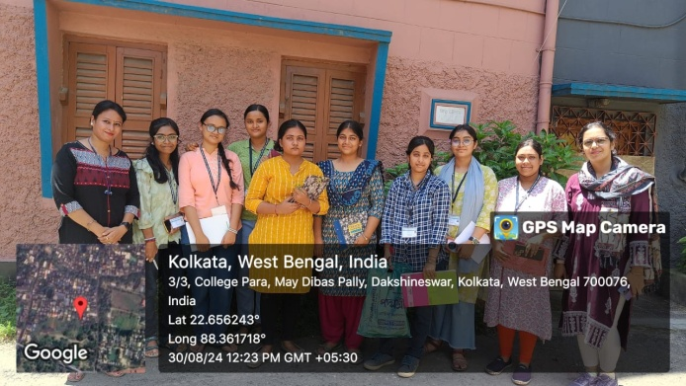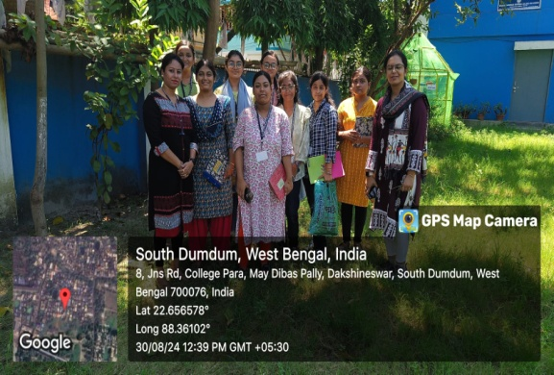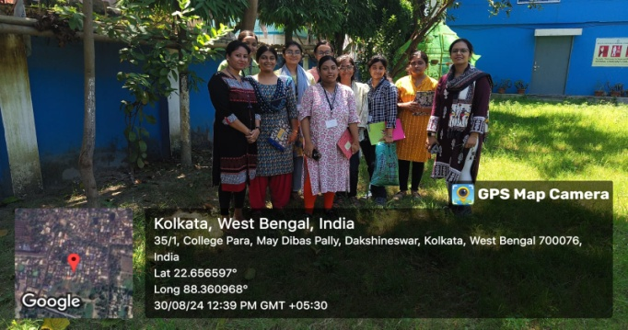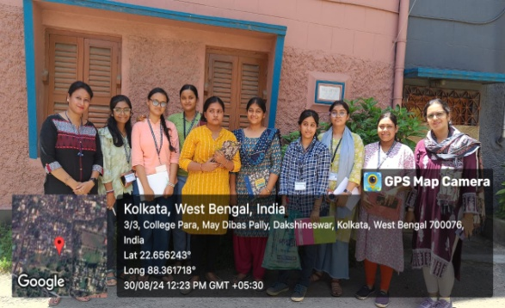

**REPORT ON VISIT TO NATIONAL FOOD LABORATORY, KOLKATA (FSSAI)**

The Department of Botany, in collaboration with the Departments of Chemistry and Food and Nutrition, Hiralal Mazumdar Memorial College for Women, Dakshineswar, organized a visit to the National Food Laboratory, Kolkata, under the Food Safety and Standards Authority of India (FSSAI), on January 3, 2025.

The visit was attended by all 3rd-semester major students, who were guided by Dr. Madhushri Das Datta. The tour commenced at approximately 11:30 am.

The primary objective of the visit was to provide students with hands-on knowledge of food safety and quality control measures. During the tour, students gained insights into:

1. Food testing and analysis

2. Quality control protocols

3. Regulatory compliance in the food industry

Students had the opportunity to interact with experts and learn about the latest techniques and methodologies used in food safety testing. The visit helped bridge the gap between theoretical knowledge and practical applications in the food industry.

The visit to the National Food Laboratory, Kolkata, was an enriching experience for the students, providing valuable exposure to the field of food safety and quality control. The Department of Botany, Chemistry, and Food and Nutrition would like to express its gratitude to the authorities and staff of the National Food Laboratory for their support and hospitality.

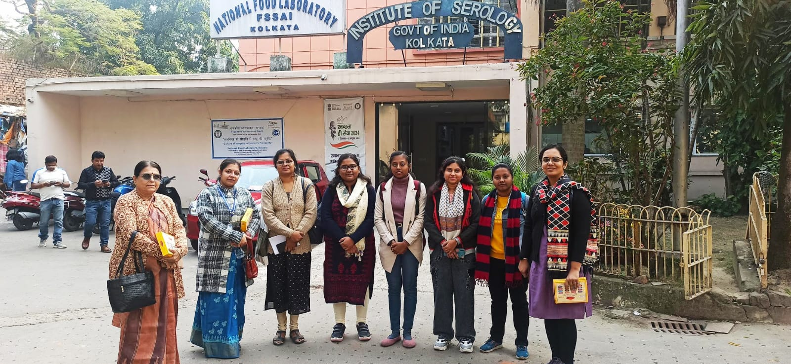

**REPORT ON EDUCATIONAL TOUR TO AJC BOSE INDIAN BOTANIC GARDEN**

The Department of Botany, Hiralal Mazumdar Memorial College for Women, Dakshineswar, organized a study excursion to the Acharya Jagadish Chandra Bose Indian Botanic Garden, in collaboration with the Botanical Survey of India (BSI), on January 17, 2025.

The excursion commenced at 10:30 am. A total of 17 students from the 1st and 3rd semesters, both major and minor, participated in the excursion under the guidance of the faculty members of the Department of Botany.

The excursion aimed to provide students with a comprehensive understanding of botanical diversity, taxonomy, and conservation. During the visit, students had the opportunity to explore the vast collection of plant species, interact with experts, and gain hands-on experience in plant identification and classification.

The excursion proved to be an enriching experience for the students, providing them with valuable insights into the field of botany. The Department of Botany would like to express its gratitude to the authorities of the Acharya Jagadish Chandra Bose Indian Botanic Garden and the Botanical Survey of India for their support and cooperation.

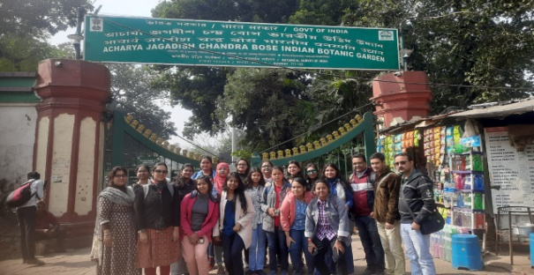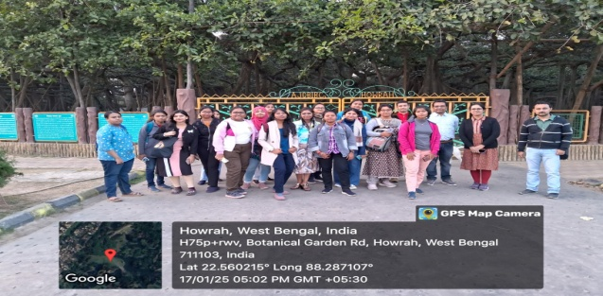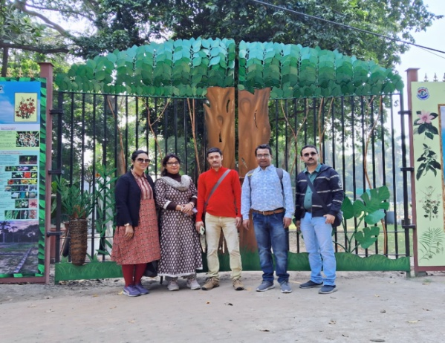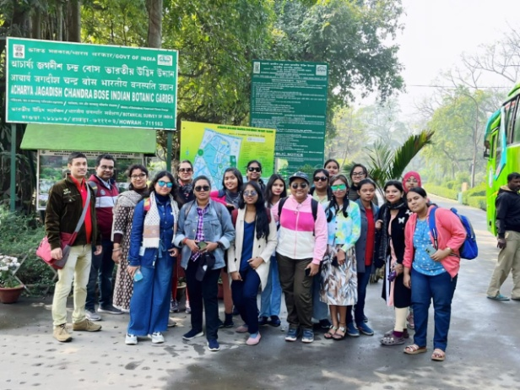

**REPORT ON INDUSTRIAL VISIT TO BISKFARM FACTORY**

The Department of Botany, in collaboration with the Departments of Chemistry and Food and Nutrition, Hiralal Mazumdar Memorial College for Women, Dakshineswar, organized a short industrial visit to Biskfarm Factory, Dhulagori, on February 7, 2025.

The visit was attended by all 3rd-semester major students, who were accompanied by Dr. Madhushri Das Datta. The tour commenced at approximately 11:00 AM.

The primary objective of the visit was to provide students with practical insights into the food industry, specifically the baking sector. During the tour, students gained valuable knowledge about:

1. Food processing and manufacturing

2. Quality control measures

3. Industrial-scale baking techniques

The visit to Biskfarm Factory proved to be an enriching experience for the students, bridging the gap between theoretical knowledge and industrial practices. The Department of Botany, Chemistry, and Food and Nutrition would like to express its gratitude to the management and staff of Biskfarm Factory for their hospitality and support.

This industrial visit has sparked interest among students to explore career opportunities in the food industry. Future visits can be planned to explore other industries, further enhancing students' understanding of practical applications.

